1. Project Identity & Abstract

🔹 Formal Title
Smart Health Tracker: A Client-Side Web Application Using HTML, CSS, and JavaScript

🔹 Executive Summary

This project is a client-side web application designed to help users track essential health metrics such as BMI, daily steps, and water intake. Built entirely using HTML, CSS, and JavaScript, the application provides a simple and interactive interface without requiring any backend server. Users can input their daily health data, and the system processes it instantly using JavaScript logic. The data is stored locally in the browser using LocalStorage, ensuring privacy and offline accessibility. The application promotes health awareness by offering quick insights and maintaining a history of user records.

2. Problem Rationale & Objectives

🔹 Problem Statement
Most health tracking applications require installation, login, and internet access. This limits accessibility and raises privacy concerns. A lightweight web-based solution that works offline and does not require authentication can improve usability and user trust.

🔹 SMART Objectives
- Develop a fully functional health tracker using HTML, CSS, and JavaScript within 2 weeks
- Implement real-time BMI calculation with instant UI updates
- Store and retrieve data using LocalStorage with 100% persistence
- Ensure responsive design across all devices
- Achieve page load time under 2 seconds

3. Functional Requirements

🔹 User Management
- No login required (Guest mode)
- Data stored per browser using LocalStorage

🔹 Core Logic (JavaScript)
- Accept user input (weight, height, steps, water)
- Calculate BMI dynamically
- Display result instantly
- Save daily records

🔹 Data Handling
- Use LocalStorage
- JSON format storage
- Auto-load previous data

4. Non-Functional Requirements
- 📱 Responsive design using CSS
- ⚡ Fast and lightweight
- 🌐 Cross-browser support

5. System Architecture

🔹 Technology Stack
- HTML5 → Structure
- CSS3 → Styling & layout
- JavaScript → Logic & storage

🔹 Data Flow
User Input → JavaScript Processing → BMI Calculation
→ Save to LocalStorage → Display History

💻 6. IMPLEMENTATION (HTML, CSS, JAVASCRIPT)

🌐 HTML (index.html)
<!DOCTYPE html>
<html lang="en">
<head>
<meta charset="UTF-8">
<title>Smart Health Tracker</title>
<link rel="stylesheet" href="style.css">
</head>
<body>

<div class="container">
<h1>Smart Health Tracker</h1>

<div class="form">
<input type="number" id="weight" placeholder="Weight (kg)">
<input type="number" id="height" placeholder="Height (cm)">
<input type="number" id="steps" placeholder="Steps">
<input type="number" id="water" placeholder="Water Intake (L)">
<button onclick="addData()">Add Data</button>
</div>

<div class="result">
<h3>BMI: <span id="bmi">0</span></h3>
</div>

<div class="history">
<h2>History</h2>
<ul id="historyList"></ul>
</div>

</div>

<script src="script.js"></script>
</body>
</html>

CSS (style.css)
body {
font-family: Arial;
background: #f4f7f9;
text-align: center;
}

.container {
width: 350px;
margin: auto;
background: white;
padding: 20px;
margin-top: 50px;
border-radius: 10px;
box-shadow: 0 0 10px rgba(0,0,0,0.1);
}

input {
width: 90%;
padding: 10px;
margin: 5px;
}

button {
padding: 10px 20px;
background: #28a745;
color: white;
border: none;
cursor: pointer;
}

button:hover {
background: #218838;
}

.history {
text-align: left;
margin-top: 20px;
}

JavaScript (script.js)
function addData() {
let weight = document.getElementById("weight").value;
let height = document.getElementById("height").value;
let steps = document.getElementById("steps").value;
let water = document.getElementById("water").value;

if (!weight || !height) {
alert("Please enter weight and height");
return;
}
// BMI Calculation
let bmi = (weight / ((height / 100) ** 2)).toFixed(2);
document.getElementById("bmi").innerText = bmi;

// Save Data
let data = {
weight,
height,
steps,
water,
bmi,
date: new Date().toLocaleDateString()
};

let history = JSON.parse(localStorage.getItem("healthData")) || [];
history.push(data);
localStorage.setItem("healthData", JSON.stringify(history));

displayHistory();
}

function displayHistory() {
let history = JSON.parse(localStorage.getItem("healthData")) || [];
let list = document.getElementById("historyList");
list.innerHTML = "";

history.forEach(entry => {
let li = document.createElement("li");
li.innerText = `${entry.date} - BMI: ${entry.bmi}, Steps: ${entry.steps}, Water: ${entry.water}L`;
list.appendChild(li);
});
}
// Load history on page load
displayHistory();

7. Screenshot (What to Submit)
Take screenshots of:
- Input form
- BMI result
- History list
- Code files
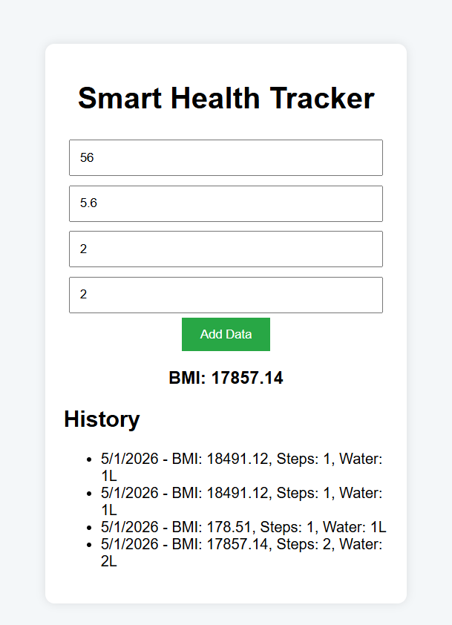

8. Conclusion
This project demonstrates how HTML, CSS, and JavaScript can be combined to create a fully functional, client-side health monitoring system. It eliminates the need for backend infrastructure while still providing useful features such as data persistence and real-time calculations. The application is simple, efficient, and scalable for future enhancements.

Thanks!

